Table 1. Specifications harvesters used in the experiment. Cáceres, Mato Grosso, 2012.
HARVESTER | YEAR/AGE | TRACK SYSTEM | PLATFORM WIDTH (m)
John Deere 1550 | 2006 | Radial | 6.90
Valtra BC 7500 | 2011 | Axial | 9.10

Table 2. Analysis of variance for descriptive variables losses caused by the cutting deck, separation and cleaning (PSL) and total loss (PT), depending on travel speed and track system of two harvesters. Cáceres, Mato Grosso, 2012.
F.V. | GL | PSL | PT
Harvester (C) | 1 | 8.31* | 7.96*
Speed (V) | 1 | 0.67 ^{ns} | 0.37 ^{ns}
C x V | 1 | 2.09 ^{ns} | 1.75 ^{ns}
RESIDUE | 9 | 92.72 | 96.96
TOTAL | - | 1927.62 | 1878.30
AVERAGE | - | 45.67 | 47.72
CV (%) | - | 21.08 | 20.63
^{ns} Not significant. * Significant at 5% probability.

Table 3. Synthesis of analysis of variance and test for variables losses caused by the cutting deck, separation and cleaning (PSL) and total loss (PT), caused by the harvester as a function of travel speed and trail system. Cáceres, Mato Grosso, 2012.
FACTORES | PSL | PT
FACTORES | ------------- kg ha⁻¹ -------------
Harvester (C)
Valtra 7500/2011 (C1) | 38.73 b | 40.77 b
John Deere 1550/2006 (C2) | 52.61 a | 54.66 a
Speed (V)
5,5 km/h (V1) | 47.64 a | 49.23 a
7,0 km/h (V2) | 43.70 a | 46.21 a
Means followed by the same letter in the column do not differ by Tukey test at 5% probability.

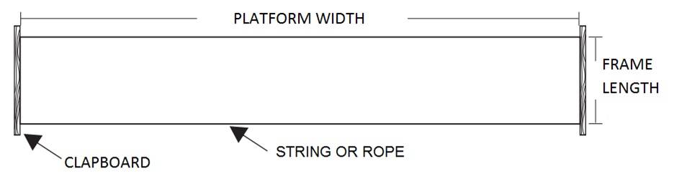
Figure 1. Frame 2.0 m² for the determination of grain losses in soybean crop.

