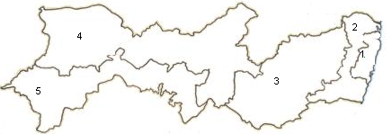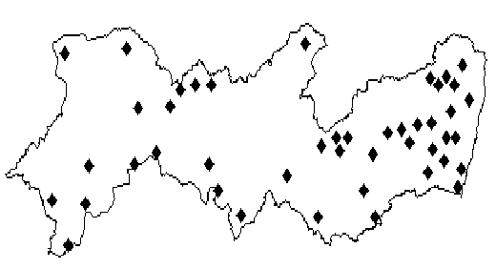
A
B
Figure 1. (A) Map of Pernambuco State divided by Mesoregions: Metropolitan (1), Zone of Forest (2), Agreste (3), Sertão (4) and Sertão of San Francisco (5). (B) SUDENE climatological stations in the state of Pernambuco.

A.
B.
D.
C.
Figure 2. Annual rainfall probability distribution for the regions: (A) Zone of Forest, (B) Agreste, (C) Sertão and (D) Sertão of San Francisco.

A.
B.
C.
D.
Figure 3. Mesoregions pluviometric regime for wet years: (A) Zone of Forest, (B) Agreste, (C) Sertão and (D) Sertão of San Francisco.

D.
C.
B.
A.
Figure 4. Monthly potential evapotranspiration for wet years: (A) Zone of Forest, (B) Agreste, (C) Sertão and (D) Sertão of San Francisco.
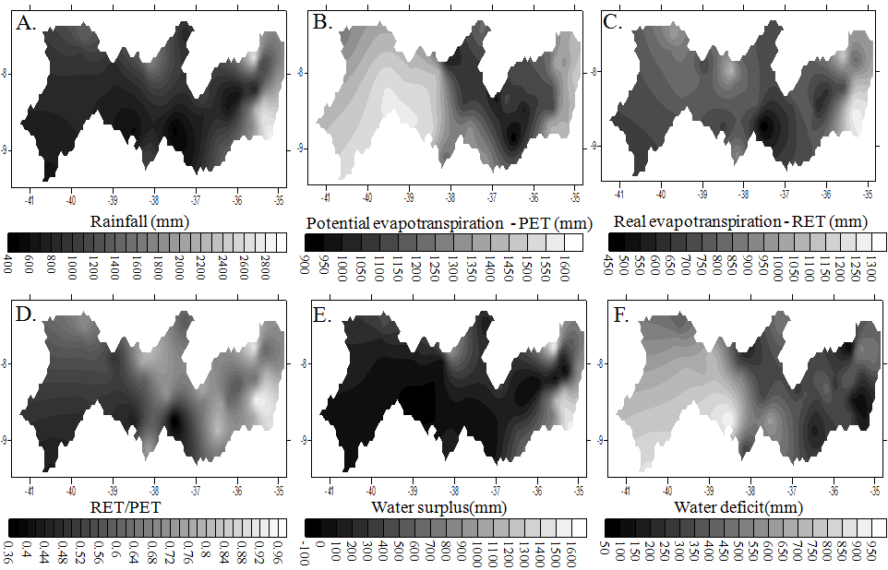
Figure 5. (A) Spatial distributions of annual precipitation in Pernambuco State; (B) Potential evapotranspiration; (C) Real evapotranspiration; (D) water availability (RET / PET); (E) water surplus and (F) water deficit for wet years obtained by kriging.

A.
B.
D.
C.
Figure 6. Mesoregions pluviometric regime for regular years: (A) Zone of Forest, (B) Agreste, (C) Sertão and (D) Sertão of San Francisco.

D.
C.
A.
B.
Figure 7. Potential evapotranspiration for years with regular rainfall: (A) Zone of Forest, (B) Agreste, (C) Sertão and (D) Sertão of San Francisco.
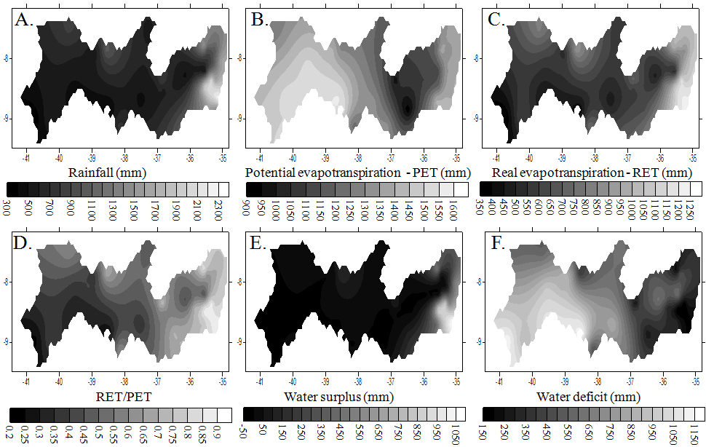
Figure 8. (A) Spatial distributions of annual precipitation in Pernambuco State; (B) Potential evapotranspiration; (C) Real evapotranspiration; (D) water availability (RET / PET); (E) water surplus and (F) water deficit for regular years.

Figurae 9. Mesoregions pluviometric regime for dry years: (A) Zone of Forest, (B) Agreste, (C) Sertão and (D) Sertão of San Francisco.

C.
D.
A.
B.
Figure 10. Potential evapotranspiration for dry years: (A) Zone of Forest, (B) Agreste, (C) Sertão and (D) Sertão of San Francisco.
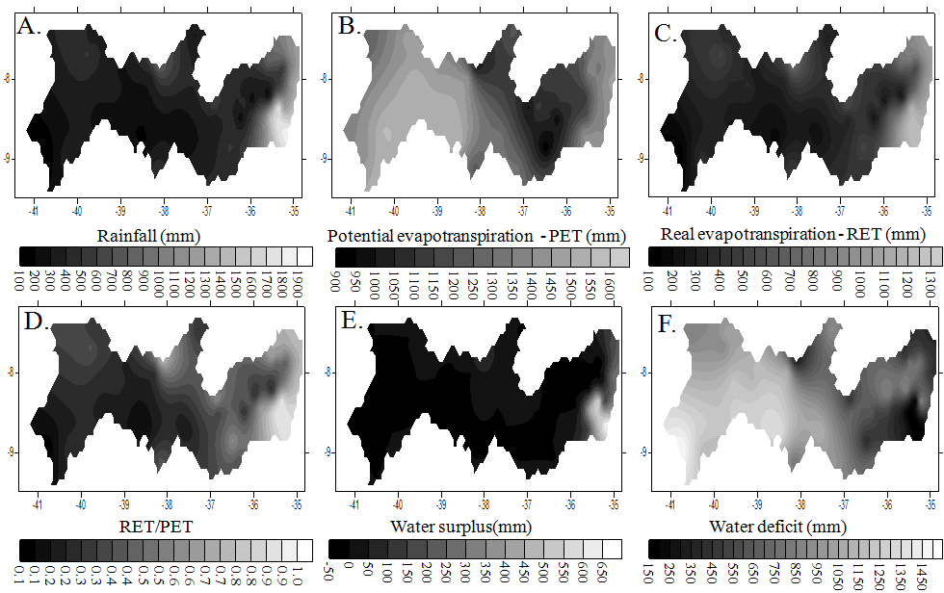
Figure 11. (A) Spatial distributions of annual precipitation in Pernambuco State; (B) Potential evapotranspiration; (C) Real evapotranspiration; (D) water availability (RET / PET); (E) water surplus and (F) water deficit for dry years.

