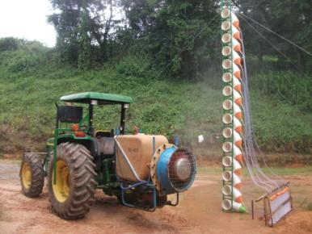
Figure 1. Vertical collector used in determining the volumetric distribution uniformity.

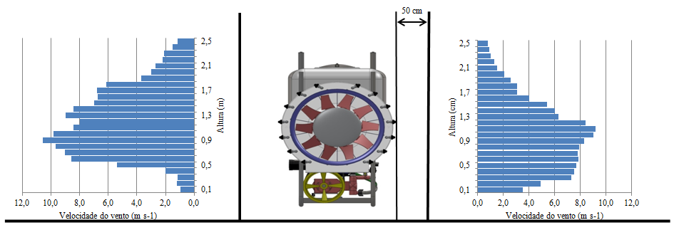
Figure 2. Speed vertical distribution of air at 0.5 m from the outlet of the fan.

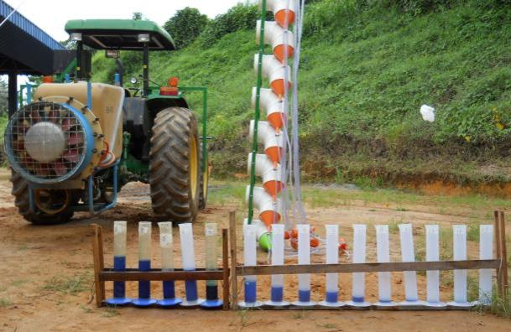
Figure 3. Device used to measure the uniformity of volumetric distribution vertical.

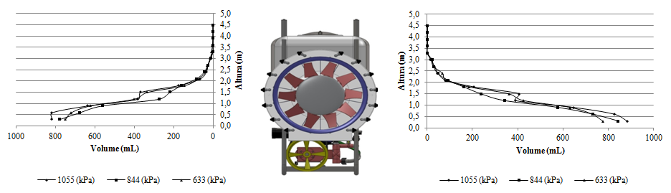
Figure 4. Uniform volumetric distribution vertical.

