Table 1. Initial population of plants (plants ha-1) in function of management systems.
Sistemas de manejo | Velocidades na operação de semeadura
Sistemas de manejo | 3 km h⁻¹ | 5 km h⁻¹ | 6 km h⁻¹ | 8 km h⁻¹ | Médias
SDh | 47.142,75 | 35.714,25 b | 33.214,50 b | 26.428,75 | 35.625,06
SDd | 47.499,75 | 37.857,25ab | 37.500,00ab | 25.357,25 | 37.053,56
CR | 49.285,50 | 41.785,50ab | 34.493,00ab | 26.785,75 | 38.087,44
CC | 50.535,75 | 44.210,50a | 42.142,75a | 28.571,25 | 41.365,06
DMS average = 5.873,56 and DMS interaction = 7.833,26; CV management systems (%) = 13,99; CV speeds on seeding operation (%) = 10,81.

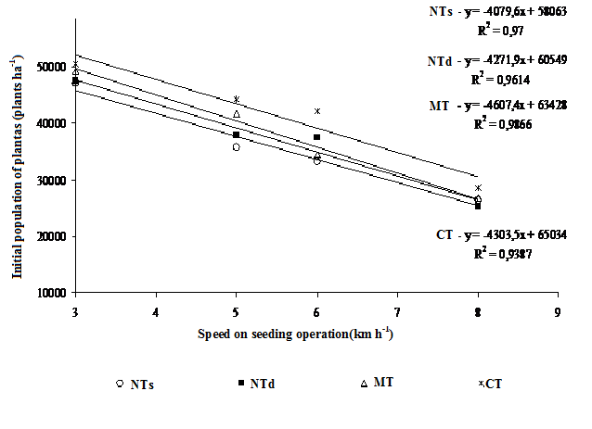
Figure1. Initial population of plants in function of speeds on seeding operation.

Table 2. Final population of plants ( plants ha⁻¹) in function of management systems.

Sistemas de manejo | Velocidades na operação de semeadura
Sistemas de manejo | 3 km h⁻¹ | 5 km h⁻¹ | 6 km h⁻¹ | 8 km h⁻¹ | Médias
SDh | 42.678,50 | 32.142,75 b | 28.571,25 b | 22.499,75 | 31.473,06 b
SDd | 43.928,50 | 33.750,00 b | 34.642,75ab | 21.785,00 | 33.526,75ab
CR | 47.857,00 | 37.500,00ab | 29.470,25 b | 22.752,00 | 34.395,00ab
CC | 48.571,00 | 41.428,75a | 37.500,00a | 24.107,25 | 37.901,75a
Means followed by the same lowercase letter in column, do not differ statistically between themselves by Tukey test the probability 5.

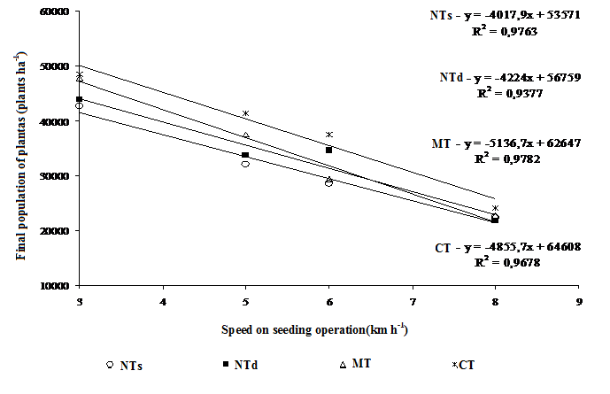
Figure 2. Final population of plants in function of speeds on seeding operation.

Table 3. Height of plants (cm) in function of management systems.
Sistemas de manejo | Velocidades na operação de semeadura
Sistemas de manejo | 3 km h⁻¹ | 5 km h⁻¹ | 6 km h⁻¹ | 8 km h⁻¹ | Médias
SDh | 145,25 | 138,50 | 145,19 | 148,88 | 144,45
SDd | 144,69 | 137,63 | 141,13 | 141,81 | 141,31
CR | 135,88 | 138,56 | 137,25 | 142,06 | 138,44
CC | 135,25 | 138,88 | 144,19 | 142,31 | 140,16
DMS average = 10,68 e DMS interation = 19,27; CV management systems (%) = 6,86; CV speeds on seeding operation (%) = 7,17.
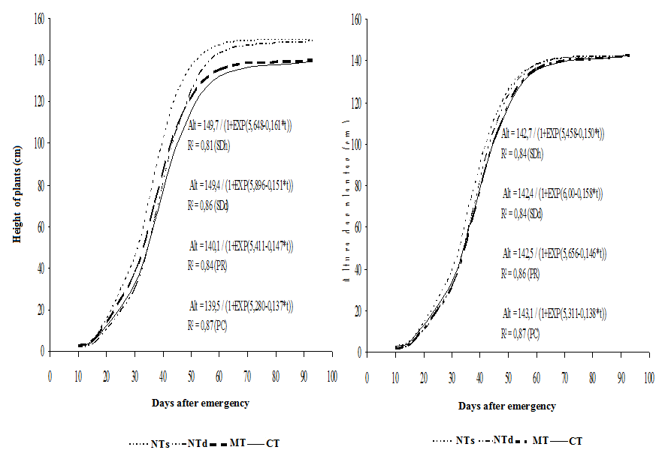
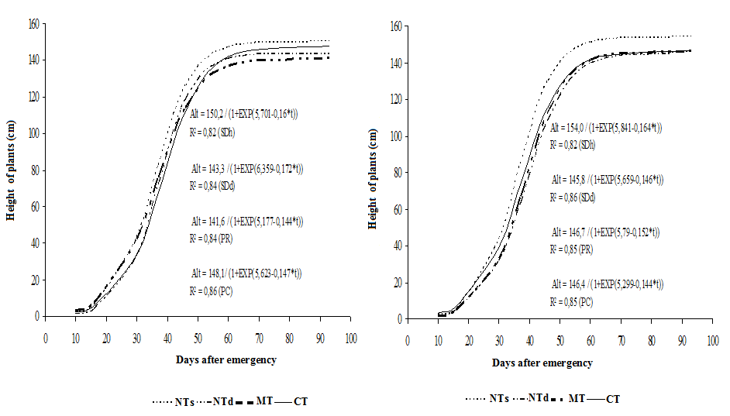

Figure 3. Height of plants (cm) in function of management systems.

Table 4. Stem diameter plants (cm) in function of management systems.
Sistemas de manejo | Velocidades na operação de semeadura
Sistemas de manejo | 3 km h⁻¹ | 5 km h⁻¹ | 6 km h⁻¹ | 8 km h⁻¹ | Médias
SDh | 2,02a | 2,21 | 2,35 | 2,78a | 2,38
SDd | 2,14ab | 2,14 | 2,13 | 2,24 b | 2,16
CR | 2,02ab | 2,19 | 2,29 | 2,34ab | 2,21
CC | 1,71 b | 2,07 | 2,02 | 2,25 b | 2,01
DMS average = 0,43 e DMS interation = 0,46; CV management systems (%) = 17,76; CV speeds on seeding operation(%) = 11,02

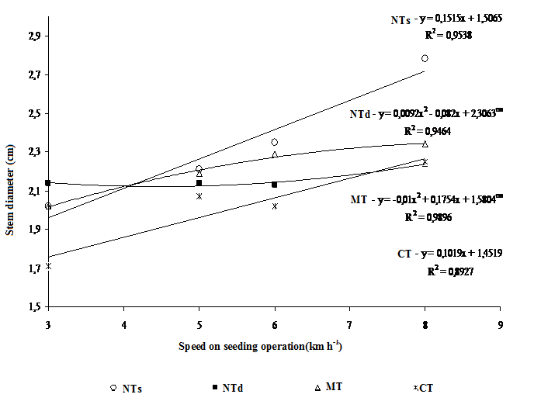
Figure 4. Stem diameter plants (cm) in function of speeds on seeding operation.

Table 5. Average values of productivity of sunflower achenes (kg ha⁻¹).
Sistemas de manejo | Velocidades na operação de semeadura
Sistemas de manejo | 3 km h⁻¹ | 5 km h⁻¹ | 6 km h⁻¹ | 8 km h⁻¹ | Médias
SDh | 1.309,75a | 1.371,25a | 1.321,50a | 1.244,25a | 1.311,69a
SDd | 1.260,75a | 1.294,50ab | 1.143,50 b | 1.033,25 b | 1.183,00ab
CR | 1.172,25ab | 1.156,00 bc | 959,00 c | 899,75 b | 1.046,75 bc
CC | 1.068,25 b | 1.126,00 c | 1.054,50 bc | 906,50 b | 1.038,81 c
Means followed by the same lowercase letter in column, do not differ statistically between themselves by Tukey test the probability 5.

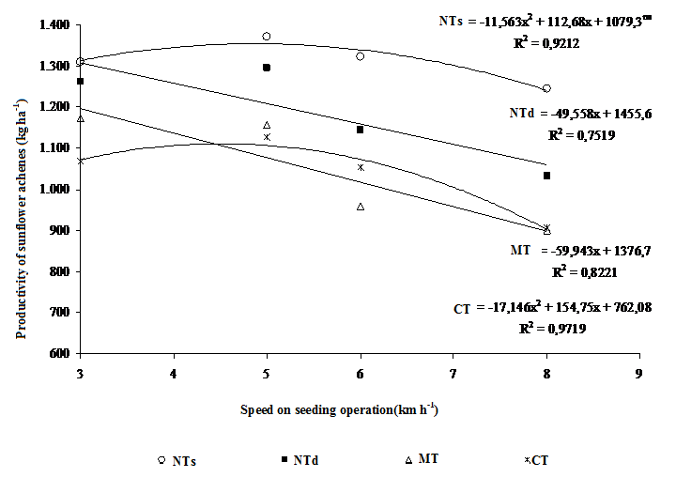
Figure 5. Productivity of sunflower achenes (kg ha⁻¹) in function of speeds on seeding operation.

