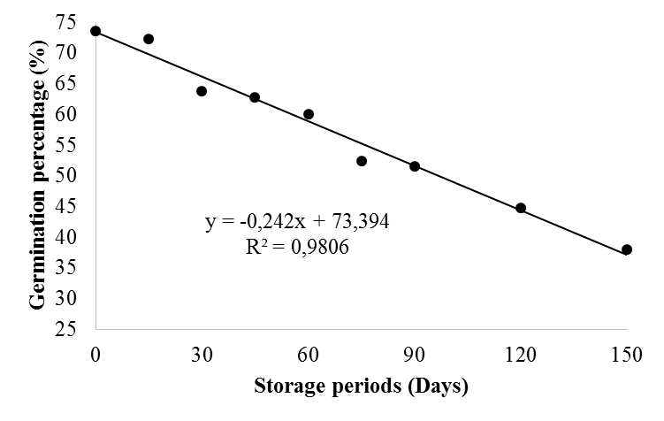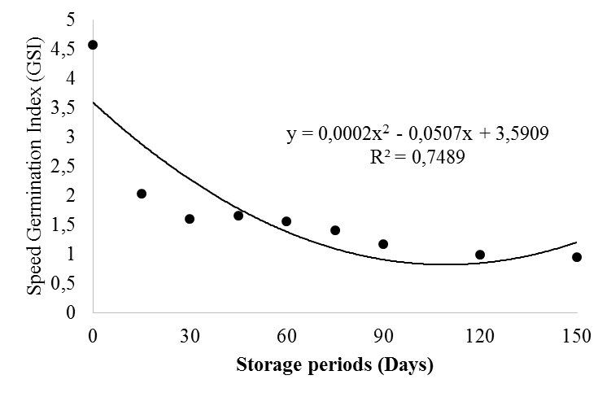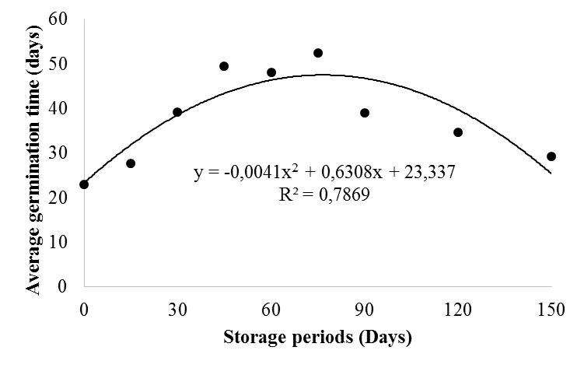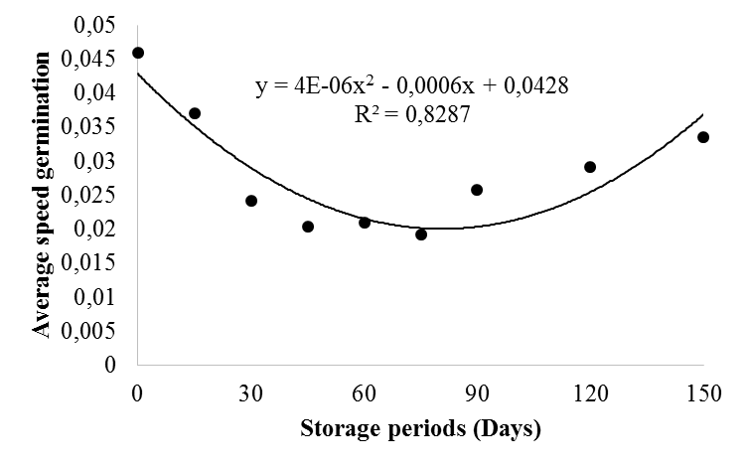
D
B
A
C
Figure 1. Germination percentage (%) (E), Speed Germination Index (GSI) (B), germination mean time (C) and average speed of germination (D) of guava seeds of white pulp depending on the storage periods.

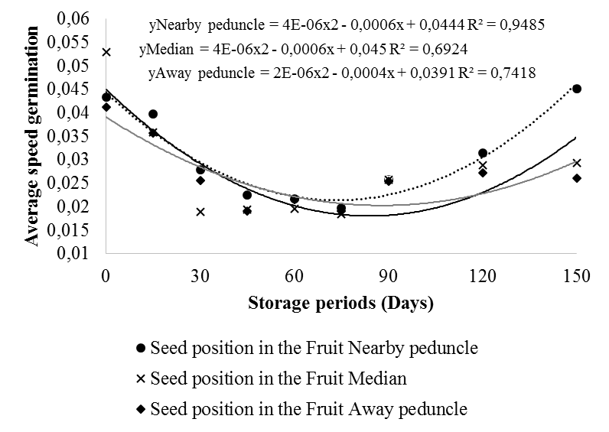
Figure 2. Average speed of seed germination of white flesh guava according to the place of collection of seeds in the fruit and storage periods.

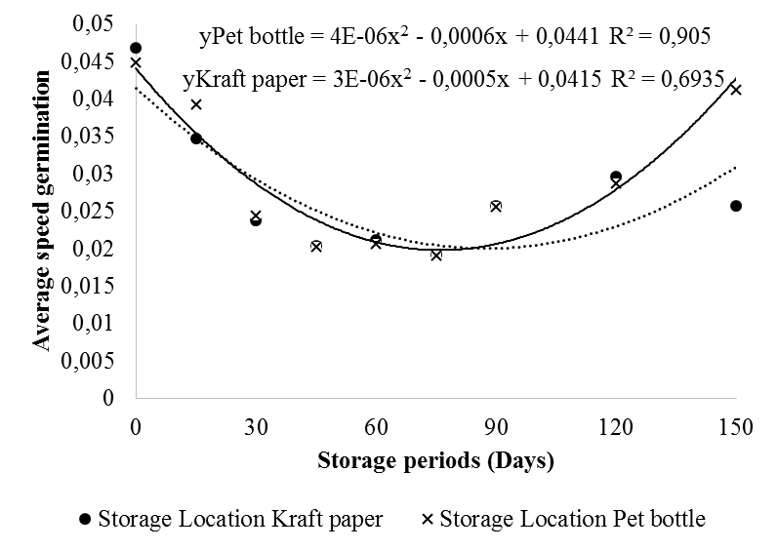
Figure 3. Average speed of germination of white pulp of guava seeds seeds depending on the storage location of the site and the storage periods.

